Congratulations to All our Winners!

On the 9th April 2021, The Store Group has hosted a lucky draw ceremony in conjunction with their 52nd Anniversary Celebration Contest that was held last year with the theme "We Thanked, We Gift" for the period from 3rd September 2020 - 2nd December 2020.
The contest were opened for all our customers who spent a minimum of RM50 or above in a single receipt at any of The Store / Pacific / Market Place by The Store / Market Place by Pacific, TS Concept Store / Superjimat outlets (except tenanted counters). Customers just needed to fill in their details (which include their name, identity card number, and their telephone number in order to stand a chance to win great prizes from our 2-tier Rewards - "Lucky Rewards" , and "Surprise Rewards" respectively.
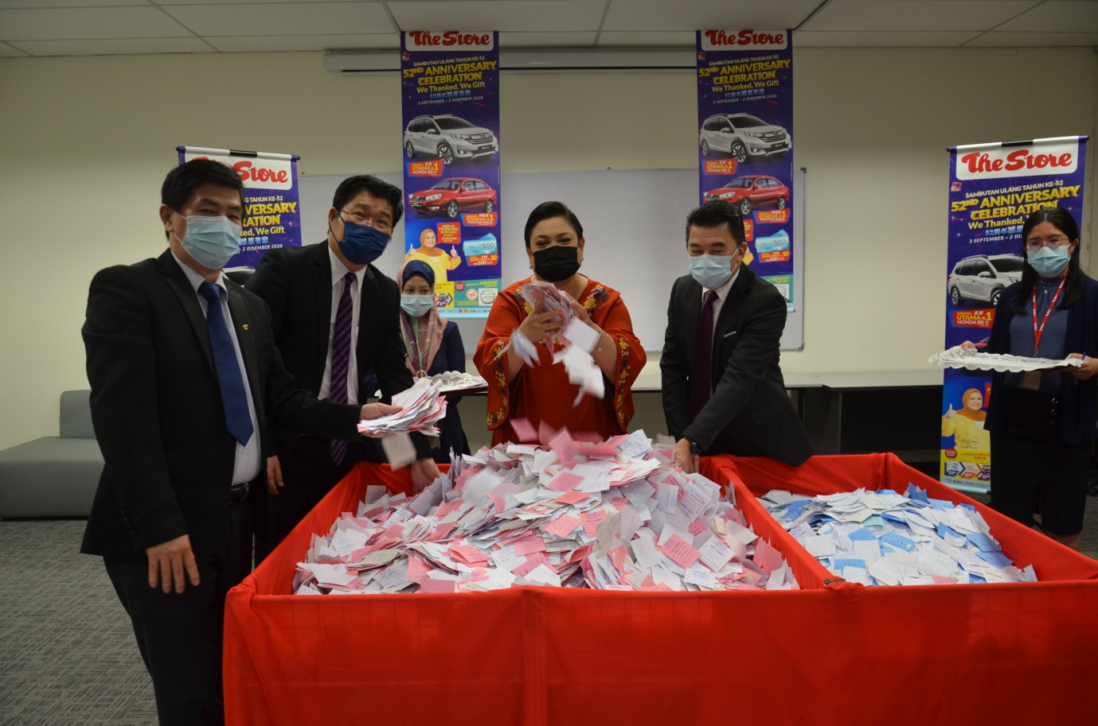
During the ceremony, our most honorable brand ambassador, Ms Adibah Noor, together with our VIP guests, Mr. Yap Choon Meng, The Store Group's General Manager, Operations; Mr. Lim Kok Soon, The Store Group's General Manager (for Softline & Hardline department); and Mr. Mark Loo Soon Hock, The Store Group's General Manager (for Supermarket Department), were all present to conduct the lucky draws for our fellow potential winners.

On the 19th April 2021, the winners for our Lucky Draw prizes were officially made available in our nationwide coverage. Our Grand Prize winner goes to Muhammad Hafizzudin Bin Hasron Hairi (I/C no. ending 0327) who would be taking home 1 unit of Honda BR-V, followed by our Special Prize winner, Loh Chwe Chu (I/C no. ending 5270) who would take home 1 Unit of Proton Saga 1.3 Standard CVT.

Last but not least, our lucky 10 Consolation Prizes are listed as per below:

1. Anis Aliah Binti Mohd Zaid (I/C no. ending 5840)
2. Fazrin Suzain Bin Supian (I/C no. ending 5193)
3. Maimun Hanum Binti Ghazali (I/C no. ending 5236)
4. Mardziah Binti Shokor (I/C no. ending 5088)
5. Nor Laila Binti Sumadi (I/C no. ending 5260)
6. Nur Liyana Binti Khairul Radzi (I/C no. ending 0438)
7. Nurul Nadia Binti Jalil (I/C no. ending 6978)
8. Nurul Nadjwa Binti Mohd Zahir (I/C no. ending 5710)
9. Pan Sow Fong (I/C no. ending 5228)
10. Tay Soon Kiong (I/C no. ending 5287)

A prize giving ceremony for our Grand Prize and Special Prize winner shall be hosted on a tentative date which to be confirmed soon.
As for our consolation prize winners, they may redeem their respective RM500 Gift Vouchers at the designated outlets near their place of residence.
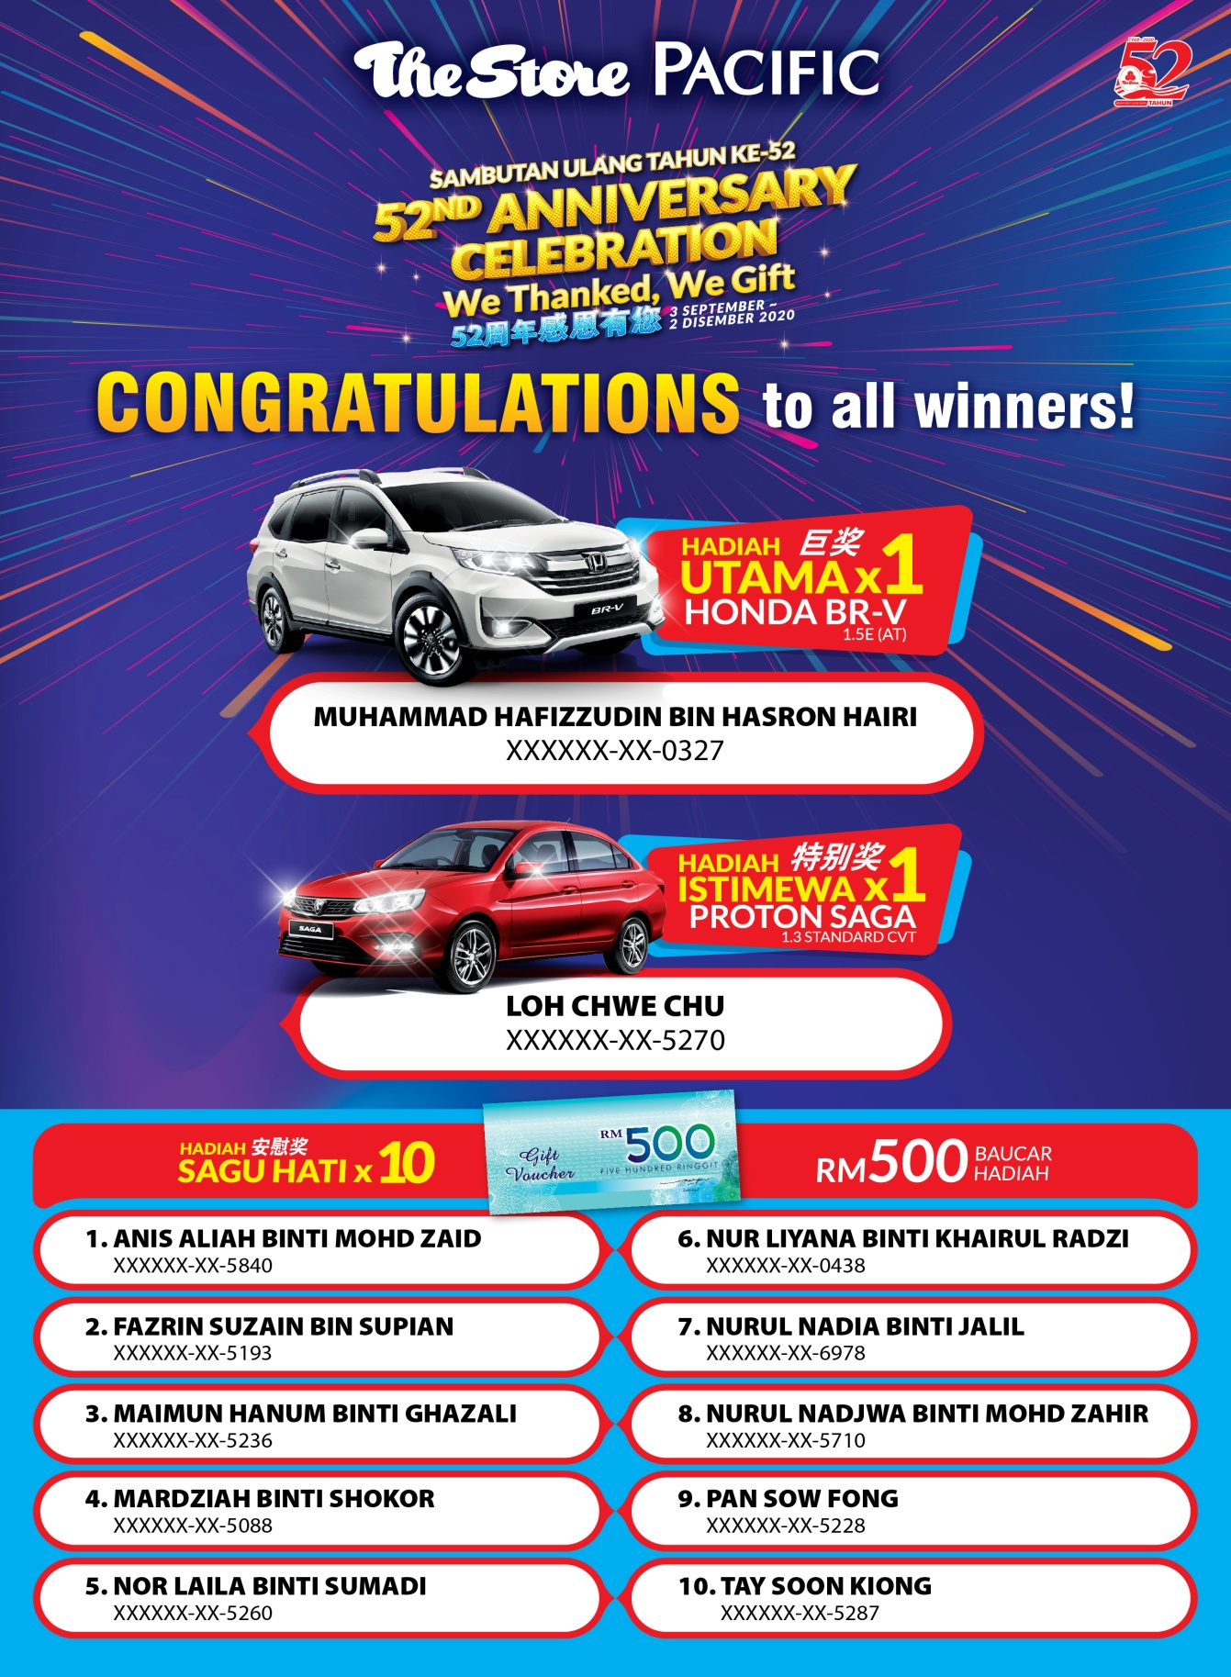
Last by not least, The Store Group management and their staff would like to thank all our customers who have participated in our 52 Anniversary Contest with the theme "We thanked, We Gift" and also congratulate all our lucky winners as per mentioned above.

